**Machine Learning for reading receipts**

**Introduction**

Receipt(the hard copies) is a very regular item that many customers receive and contain huge amount of information. But the most difficult challenge is identification of data which is unstructured. This solution deals with classification of receipts based on an item purchased by the user- in this scenario receipt images are classified based on Milk buying or Milk Non-buying groups. Classifying the receipts could be very challenging due to fuzzy visibility when compared with the regular documents and a wide variety of fonts.

This model could be very useful for the reimbursement companies to validate and provide reimbursement for particular products identified in the receipts. For instance this particular model could be used for the USDA Milk Donation Reimbursement Program(MDRP). And intuition can be applied in many similar circumstances.

This paper narrates the data pipeline for identifying and separating the receipt in the scanned image from the background, cropping the image and extracting the core region of the image to identify if milk is present in the receipt and augmenting the images for generating data required for model. Finally Deep learning models are applied to classify and predict the presence of the product in the image.

We have attempted to implement the concept of Input image data > Output classes (instead of Input data > Extract required text > Output classes) in this project (reference Andrew Ng’s video on Deep learning)

**Related work in detail**

**Academic**

* This research paper by Dr.Alex Yue from Princeton Universitydetails out the process of reading receipts using Machine learning
  + [**https://www.cs.princeton.edu/courses/archive/spring18/cos598B/public/projects/System/COS598B_spr2018_ReceiptParsing.pdf**](https://www.cs.princeton.edu/courses/archive/spring18/cos598B/public/projects/System/COS598B_spr2018_ReceiptParsing.pdf)
* This research paper focused on Convolutional Neural Network for Image classification at scale
  + [**http://papers.nips.cc/paper/4824-imagenet-classification-with-deep-convolutional-neural-networks.pdf**](http://papers.nips.cc/paper/4824-imagenet-classification-with-deep-convolutional-neural-networks.pdf)
* Even though the following is not receipt related, it is related to invoice and some of the concepts could be used
  + [**http://cs229.stanford.edu/proj2016/report/LiuWanZhang-UnstructuredDocumentRecognitionOnBusinessInvoice-report.pdf**](http://cs229.stanford.edu/proj2016/report/LiuWanZhang-UnstructuredDocumentRecognitionOnBusinessInvoice-report.pdf)
* Focus Enhanced Scene Text Recognition with Deformable Convolutional Neural Network
  + <https://arxiv.org/pdf/1908.10998v2.pdf>
* Detecting text in images using convolutional networks
  + <http://cs231n.stanford.edu/reports/2015/pdfs/vikesh_final.pdf>
* Scene text detection and recognition: recent advances and future trends
  + <https://web.archive.org/web/20170321094647/http://mc.eistar.net/uploadfiles/Papers/FCS_TextSurvey_2015.pdf>

**Industry**

* Reading Invoices from OCR
* <https://nanonets.com/blog/invoice-ocr/>

# Comcast: <https://databricks.com/session/how-to-utilize-mlflow-and-kubernetes-to-build-an-enterprise-ml-platform>

**Methodology**

This project is comprised of methods and systems to automate image processing to feed to the Deep learning models. The purpose of doing it is to identify if a receipt contains an item upload as image.

The primary steps involved are:

**Preprocessing:**

Pre-processing of data is tremendously important, especially in the case of receipt related image classification models.

**Edge Detection:** Generally the receipts are scanned with diverse background. Edge detection

involves determining the foreground versus background for any given image. It assumes

1. Receipt is clearly distinguishable from the background.
2. Scanned receipt is Rectangular

Steps Involved:

* To make edge detection more accurate and quick the receipt images are resized to smaller dimensions by keeping track of the ratio resized
* The colored image is converted into grayscale and blurring is performed using gaussian filter to remove high frequency noise components reduction.
* Canny Edge detector from opencv library is used to detect the edges of the receipt

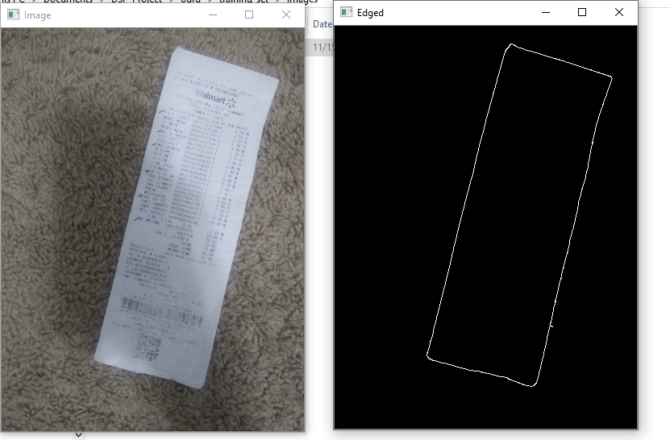

Original Image and the final image with detected edges

**Finding Contours:**

Contours are found by utilizing the edges.For detecting Contours the system assumes the following:

1. Each receipt contains Four edges( Xmin, Xmax,Ymin,Ymax)
2. We assume largest contour in the image is rectangular and with exactly four points

Steps Involved:

* All the contours are found and only the contour with maximum area is kept by looping over them

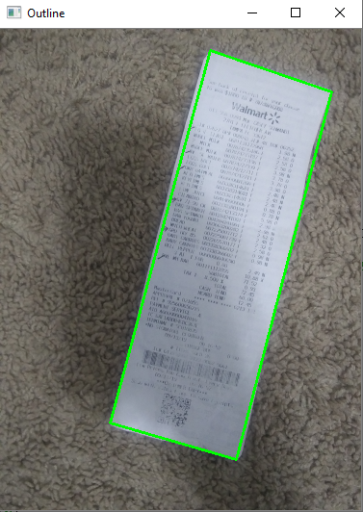

**Cropped Image:**

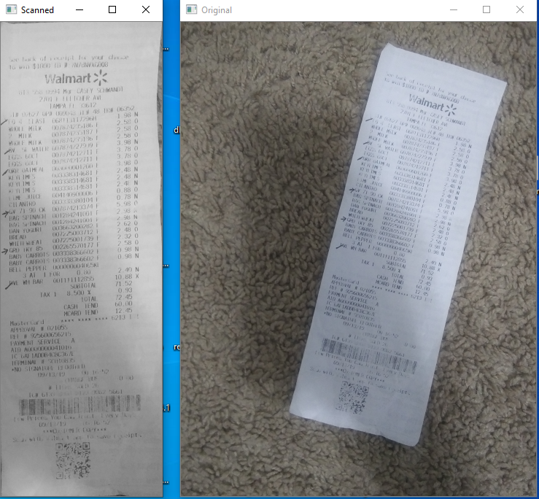

Cropped and original image

For getting the bird eye view of the image, cv2 getPerspectiveTransform is used for this purpose.Four point transform function takes in the arguments as Image and the contours identified.

Utilized four_point_transform from <https://www.pyimagesearch.com/>

**Data Generation via Augmentation**:

We were able to collect 60 Publix receipts out of which 30 were readable and distinct. For overcoming the problem of sparse dataset, data augmentation is leveraged. The receipt is cropped so that it includes the core part of the image which contains the product description. Using image processing library skimage random noise is included to generate 1000 images. Also data augmentation is performed using Keras Datagenerator method which generates noise and created additional images that are stored in the memory so that model can be trained with sufficiently high amount of data.

**Bounding Boxes and ROI’s:**

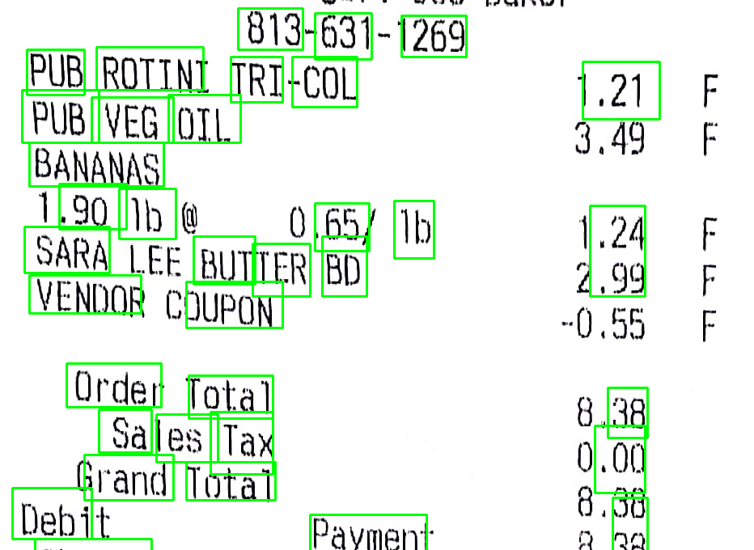

For detecting Bounding boxes East- (Efficient and accurate scene detection) deep learning model is used, output feature maps are extracted from two layers for probability

and for finding bounding box coordinates. Non max suppression is applied to bounding boxes to suppress weak overlapping boxes

**Model:**

We used Convolution Neural Network:

Following structure is used for building the CNN

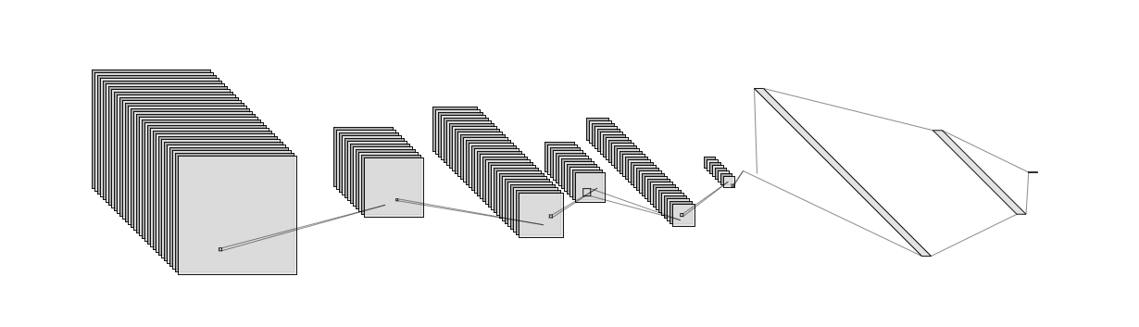

* Three convolution layers and 3 max pooling layers are used
* Convolution layer

**Through this project**

**Libraries and dependencies we used:**

* **Keras**
* **TensorFlow**
* **OpenCV**
* **Imutils**
* **Skimage**
* **Non_max_supression**
* **Tesseract**
* **Augmentor**

**Results**

Iteration 1 had overfitting problem with training and validation accuracy of 1.0 and prediction accuracy of 50%

By adding a Dropout with probability of 40%, the training and validation accuracy of 83% was received as follows

Epoch 1/5

40/40 [==============================] - 151s 4s/step - loss: 0.7826 - accuracy: **0.4914** - val_loss: 0.6936 - val_accuracy: **0.4850**

Epoch 2/5

40/40 [==============================] - 68s 2s/step - loss: 0.6724 - accuracy: **0.5603** - val_loss: 0.6888 - val_accuracy: **0.6600**

Epoch 3/5

40/40 [==============================] - 63s 2s/step - loss: 0.6149 - accuracy: **0.6584** - val_loss: 0.6237 - val_accuracy: **0.7100**

Epoch 4/5

40/40 [==============================] - 64s 2s/step - loss: 0.4233 - accuracy: **0.8155** - val_loss: 0.5009 - val_accuracy: **0.7450**

Epoch 5/5

40/40 [==============================] - 64s 2s/step - loss: 0.2544 - accuracy: **0.9010** - val_loss: 0.2801 - val_accuracy: **0.8350**

**Future work**

Applications like Facebook, Twitter and Instagram are so popular for a reason that, every individual is so curious to know how other thinks about them. In the same way, everyone is curious on how others send there money, the products they buy and the place where they buy them, brands they buy, how often they buy and the savings they do.

Now imagine a decentralised network, where the data you store can be accessed by only individuals but not the tech giants like Facebook or Amazon who pop up with ads and suggestions on every page you visit on the web. The network which does need any cloud storage and runs only with the network of the most powerful devices on the earth, our mobile phones. Every receipt you upload will be parsed, distributed and stored on every other mobile device on the planet. This could be the future of new social network, where everyone can see you expenses, your tastes, the brands you use, the amount of saving you do every month with highly secured network of no firewalls, no storage issues and a lot more which makes our earth a cheaper place to live.

**Implications**

Imagine when you place your mobile device on a receipt and it identifies all the items on it and provides you a notification that could list the places where you could buy the same items at a cheaper price. This could be achieved through decentralized network, where everyone scans there receipts on their mobile devices and all the information from the receipt that includes the organisation name, list of items they have bought and their respective prices getting stored in a decentralized database. Now the database have the details of any item and the organization where that could be bought at a cheaper price.

Sharing the receipt details with all the contacts in your mobile can provide you a dashboard on how good or bad are you at your expenses every month. Imagine your application show you a notification that says “You have saved 10$ on dairy products compared to Mrs. XXX this month”. This creates a social network of all the expenses a family is making and everyone in the family can track the expenses of other persons.

**Videos tutorials for reading receipt**

<https://www.youtube.com/watch?v=B1d9dpqBDVA>

<https://www.youtube.com/watch?v=gViXzJl5ef4>

<https://www.youtube.com/watch?v=w95ktvMyZxg>

**Receipt samples and code examples**

<https://gist.github.com/fgrehm/d3612ee6a84fc74e4595e52078040d46>

<https://dzone.com/articles/using-ocr-for-receipt-recognition>

**PySpark tutorial to run regression**

<https://www.youtube.com/watch?v=C49R0o5gE9c&feature=youtu.be>

|  |  |
| --- | --- |
| **Task** | **Status** |
| **Collect Clean Receipt samples - for CNN large volume is must**  Receipt images collected personally  <https://drive.google.com/drive/folders/1dFvgxje_YhGVS79mHf_D9maABR2kQSVc>  <https://github.com/indravz/DSP-Project>  Following public datasets could not be extracted  <http://www.cs.cmu.edu/~aharley/rvl-cdip/>  <https://rrc.cvc.uab.es/?ch=13&com=downloads>  Challenge SROIE  **To mention in the report: challenge of small number of receipts and how we overcame**   1. **Data augmentation** |  |
| Collect noise samples  Crumpled image samples  Blurred text samples |  |
| Load images to S3 or Databricks MLflow |  |
| Call Amazon API and extract Text to .csv file or Databricks API |  |
| A). Compare Sample images and match Text of Store Name and record accuracy by manual labeling - AWS extracted text |  |
| Load .csv to PySpark and Run K-Means Clustering |  |
| Train a Machine Learning algorithm on PySpark to extract text from image, identify Store name |  |
| B). Compare Sample images and match Text of Store name and record accuracy by manual labeling - manually trained ML |  |
| Supportive tasks  Identify machine learning algorithms to manually train receipt image text extraction |  |
| Model deployment  <https://databricks.com/session/how-to-utilize-mlflow-and-kubernetes-to-build-an-enterprise-ml-platform>  <https://databricks.com/blog/2019/10/17/managed-mlflow-now-available-on-databricks-community-edition.html>  <https://pytorch.org/> |  |

**References**

|  |  |
| --- | --- |
| Resources | Comments |
| Datasets and APIs  <http://www.iapr-tc11.org/mediawiki/index.php/Datasets_List> |  |
| <https://medium.com/capital-one-tech/learning-to-read-computer-vision-methods-for-extracting-text-from-images-2ffcdae11594> |  |
| <https://towardsdatascience.com/all-the-steps-to-build-your-first-image-classifier-with-code-cf244b015799> | Step by step image classification |
| <https://stackoverflow.com/questions/31633403/tesseract-receipt-scanning-advice-needed>  <https://stackoverflow.com/questions/45796771/how-to-extract-relevant-information-from-receipt>  <https://stackoverflow.com/questions/44112843/ocr-for-detecting-bills>  <https://www.youtube.com/watch?v=B1d9dpqBDVA>  **For Preprocessing of image -**  <https://likegeeks.com/python-image-processing/>  <https://docparser.com/blog/improve-ocr-accuracy/>  Building OCR:  <https://www.quora.com/What-are-the-steps-for-making-an-optical-character-recognition-OCR-from-scratch>  <https://blogs.dropbox.com/tech/2017/04/creating-a-modern-ocr-pipeline-using-computer-vision-and-deep-learning/>  <https://nanonets.com/blog/deep-learning-ocr/>  <https://hackernoon.com/latest-deep-learning-ocr-with-keras-and-supervisely-in-15-minutes-34aecd630ed8> |  |
| Convolutional Neural Network  <https://towardsdatascience.com/from-raw-images-to-real-time-predictions-with-deep-learning-ddbbda1be0e4> |  |
| Google Collab to train CNN  <https://towardsdatascience.com/tensorflow-2-0-create-and-train-a-vanilla-cnn-on-google-colab-c7a0ac86d61b> |  |
| <https://www.analyticsvidhya.com/blog/2018/04/solving-an-image-captioning-task-using-deep-learning/> |  |
| https://hackernoon.com/latest-deep-learning-ocr-with-keras-and-supervisely-in-15-minutes-34aecd630ed8 |  |
| Image generation/augmentation  <https://medium.com/@thimblot/data-augmentation-boost-your-image-dataset-with-few-lines-of-python-155c2dc1baec>  Github code for data augmentation  <https://gist.github.com/tomahim/9ef72befd43f5c106e592425453cb6aehttps://gist.github.com/tomahim/9ef72befd43f5c106e592425453cb6ae> |  |
| Paper and code for Scene text recognition  <https://paperswithcode.com/task/scene-text-recognition>  <https://github.com/Alpaca07/dtr/blob/master/train.py>  https://arxiv.org/pdf/1908.10998v2.pdf |  |
| Curated list of papers related to scene text recognition  <https://web.archive.org/web/20170207033948/https://github.com/chongyangtao/Awesome-Scene-Text-Recognition> |  |